**Level Design Document for:**

Postal Frog

All work Copyright ©2021

Written by Team AIE Production

Table of Contents

1.0 Revision History 4

2.0 level Design Overview 4

2.1 Level Design concept 4

2.2 Gameplay Mechanics 4

2.3 Camera 4

3.0 Theme and Characters 4

3.1 Characters 4

3.2 Theme 4

4.0 Level Information 5

4.1 Level Location 5

4.2 Level Setting 5

4.3 Level Layout/Architecture 5

5.0 Level Design 5

5.1 Main Objectives 5

5.2 Optional Objectives 5

5.3 WOW Moments 5

5.4 Level Progression 5

5.5 Player Experience 5

6.0 Art Style and Aesthetics 6

6.1 References 6

6.2 Lighting 6

6.3 SFX/Music 6

6.4 Particle FX 7

7.0 Level Asset List 7

8.0 Delivery Milestones 7

# 1.0 Revision History

<As you revise the document, list what was changed and when it was changed>

|  |  |
| --- | --- |
| Version | Description |
| 1.0 | Initial document |

# 2.0 level Design Overview

## 2.1 Level Design concept

Platforming level based in a hedged in townhouse with a fountain. Level focuses on gaining height to get to the final objective

## 2.2 Gameplay Mechanics

Jumping forward: player jumps forward at a set minimum amount; they can move further by holding the jump button

## 2.3 Camera

Camera will be third person and walls will disappear when necessary to give a clear view

# 3.0 Theme and Characters

## 3.1 Characters

Postal Frog: player character - helps in deliveries by sending letters and ringing doorbells

## 3.2 Theme

Animals needing to use their unique talents to deliver resources and post to a human world far off from their world scale.

# 4.0 Level Information

## 4.1 Level Location

Hedged-in townhouse

## 4.2 Level Setting

When humans cannot deliver their own mail, others must rise to the challenge… such as the **Postal Frog**

## 4.3 Level Layout/Architecture

# 5.0 Level Design

## 5.1 Main Objectives

Linear platforming level, reach objective

Climb through the level to reach the doorbell (and ring it)

## 5.2 Optional Objectives

None

## 5.3 WOW Moments

None

## 5.4 Level Progression

*<Difficulty cure, Progression Diagram or Beat Sheet>*

## 5.5 Player Experience

*<What is motivating the player? Emergent gameplay opportunities>*

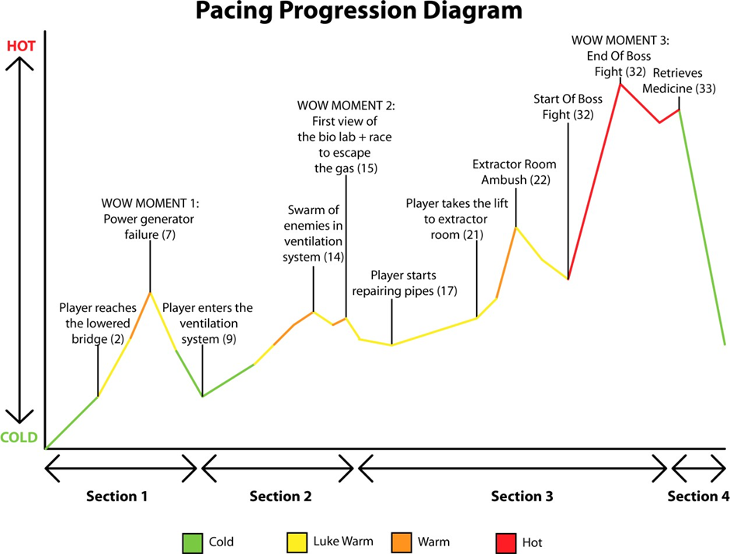

# 6.0 Art Style and Aesthetics

Refer to the Mood Boards and 2D level Design maps

## 6.1 References

<Provide images here or links to mood boards and reference images>

## 6.2 Lighting

<Color ,mood, Signposting, Narrative >

## 6.3 SFX/Music

List music clips and where they’re used.

List all sound effects and where they’re used

## 6.4 Particle FX

List particle effects and why they are used

# 7.0 Level Asset List

<Static and dynamic objects relative to the environment>

|  |  |
| --- | --- |
| Item | Description |
| Postal frog | Player character |
| fountain | 2 level platform |
| Leaves | Single leaves to use as platforms |